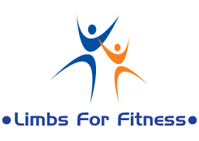
Hello,
Limbs For Fitness (LFF) is a fairly new Non-Profit organization started back in March of 2011. Limbs For Fitness’ “mission” is to “Promote a mentally and physically fit life.” This organization is fairly small at the moment, but has and continues to grow by the minute; as ABC News, Channel 9 WUSA, The Doctors and The Potomac Nationals (P-Nats) have all taken interest into the starting of this organization. Founded by Daniel Carroll, one of Prince Williams County’s most well-known motivational teens, trying to take a part in the uplifting of attitudes and spirits in all of whom he comes in contact with. This organization doesn’t ask for much, a little collaboration will help us expand to be able to help those with “disabilities” have more confident in our community. You may think a few words can change someone’s way of judgment, but a whole speech can change one persons’ point of view, and that is our goal. Help us gain that confident, to help your community. All around the world, this, is where we start!
Donations would be appreciated to help continue giving back to the community. If you would like to donate please see the below information:
*Cut on dotted line*
------------------------------------------------------------------------------------------------------------------------------------------
Personal or Company Name: __________________________________________________
I wish TO have my personal or company name kept confidential
I wish NOT TO have me personal or company name kept confidential
Personal or company E-mail: __________________________________________________
I wish to receive E-mail’s on up-to-date events and status on Limbs For Fitness
Check one:
Cash: $__________________
Check: $__________________
Make all checks payable to: Daniel Carroll-- Limbs For Fitness
Limbsforfitness.yolasite.com

