Fitness on the Water with Limbs For Fitness
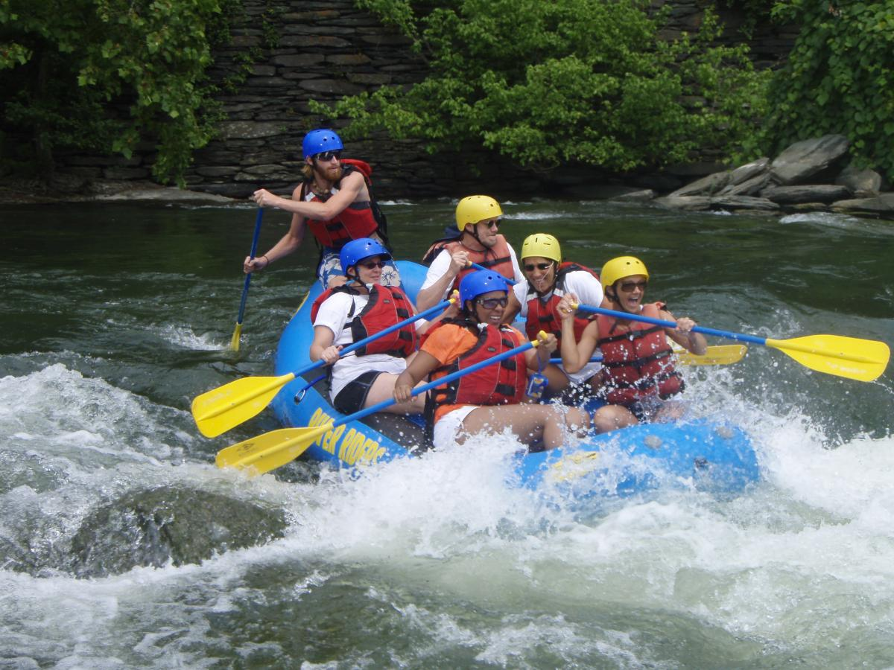

Limbs For Fitness will be holding a fitness day on August 18th
The fitness day will be held on The Beautiful Shenandoah River in Luray, Va.
The profits will go toward Limbs For Fitness' 501(c)3 number, better known as our national recognition for being a non-profit. And towards helping anonymous patients regain health and spirit through a tragedy.
Cost: $30.00 per person
*Includes safety equipment*
Sign up by July 27th!

Emergency forms and additional insurance papers will need to be completed upon registration. Must provide own transportation to and from the event. Must be 18 years or older to apply, ages 17 and under will require parental/guardian consent, ages 14 and younger must have a parents/guardian or sibling/friend (18 years or older with parental/guardian approval) to attend the event. Other restrictions may apply. First come, first serve basis. Limbs For Fitness and/or and staff member will not be responsible for lost or stolen items; injury’s or death (we will administer basic first aid upon request and may have a licensed nurse/doctor or other medically license practitioner on site).

